**Stock Market**

**Database design**

In following design contains table which we need to store data in some features. There are some features in which we are displaying data fetched using api. For such features we haven’t created tables in database.

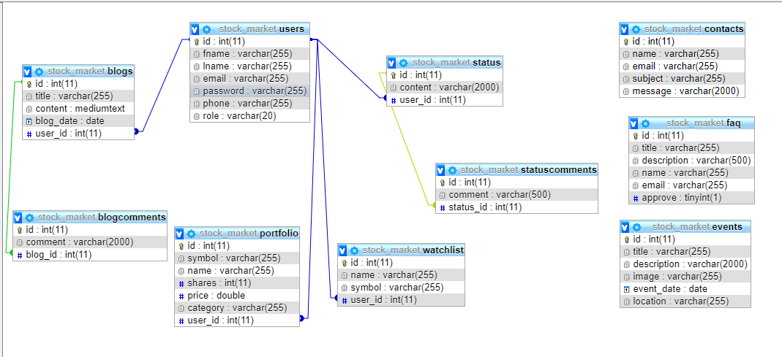

**Databse SQL code**

-- phpMyAdmin SQL Dump

-- version 4.8.4

-- https://www.phpmyadmin.net/

--

-- Host: 127.0.0.1

-- Generation Time: Mar 20, 2019 at 03:40 PM

-- Server version: 10.1.37-MariaDB

-- PHP Version: 7.3.0

SET SQL_MODE = "NO_AUTO_VALUE_ON_ZERO";

SET AUTOCOMMIT = 0;

START TRANSACTION;

SET time_zone = "+00:00";

/*!40101 SET @OLD_CHARACTER_SET_CLIENT=@@CHARACTER_SET_CLIENT */;

/*!40101 SET @OLD_CHARACTER_SET_RESULTS=@@CHARACTER_SET_RESULTS */;

/*!40101 SET @OLD_COLLATION_CONNECTION=@@COLLATION_CONNECTION */;

/*!40101 SET NAMES utf8mb4 */;

--

-- Database: `stock_market`

--

-- --------------------------------------------------------

--

-- Table structure for table `blogcomments`

--

CREATE TABLE `blogcomments` (

`id` int(11) NOT NULL,

`comment` varchar(2000) NOT NULL,

`blog_id` int(11) NOT NULL

) ENGINE=InnoDB DEFAULT CHARSET=utf8;

-- --------------------------------------------------------

--

-- Table structure for table `blogs`

--

CREATE TABLE `blogs` (

`id` int(11) NOT NULL,

`title` varchar(255) NOT NULL,

`content` mediumtext NOT NULL,

`blog_date` date NOT NULL,

`user_id` int(11) NOT NULL

) ENGINE=InnoDB DEFAULT CHARSET=utf8;

-- --------------------------------------------------------

--

-- Table structure for table `contacts`

--

CREATE TABLE `contacts` (

`id` int(11) NOT NULL,

`name` varchar(255) NOT NULL,

`email` varchar(255) NOT NULL,

`subject` varchar(255) NOT NULL,

`message` varchar(2000) NOT NULL

) ENGINE=InnoDB DEFAULT CHARSET=utf8;

-- --------------------------------------------------------

--

-- Table structure for table `events`

--

CREATE TABLE `events` (

`id` int(11) NOT NULL,

`title` varchar(255) NOT NULL,

`description` varchar(2000) NOT NULL,

`image` varchar(255) DEFAULT NULL,

`event_date` date NOT NULL,

`location` varchar(255) NOT NULL

) ENGINE=InnoDB DEFAULT CHARSET=utf8;

-- --------------------------------------------------------

--

-- Table structure for table `faq`

--

CREATE TABLE `faq` (

`id` int(11) NOT NULL,

`title` varchar(255) NOT NULL,

`description` varchar(500) NOT NULL,

`name` varchar(255) DEFAULT NULL,

`email` varchar(255) DEFAULT NULL,

`approve` tinyint(1) DEFAULT NULL

) ENGINE=InnoDB DEFAULT CHARSET=utf8;

-- --------------------------------------------------------

--

-- Table structure for table `portfolio`

--

CREATE TABLE `portfolio` (

`id` int(11) NOT NULL,

`symbol` varchar(255) NOT NULL,

`name` varchar(255) NOT NULL,

`shares` int(11) NOT NULL,

`price` double NOT NULL,

`category` varchar(255) NOT NULL,

`user_id` int(11) NOT NULL

) ENGINE=InnoDB DEFAULT CHARSET=utf8;

-- --------------------------------------------------------

--

-- Table structure for table `status`

--

CREATE TABLE `status` (

`id` int(11) NOT NULL,

`content` varchar(2000) NOT NULL,

`user_id` int(11) NOT NULL

) ENGINE=InnoDB DEFAULT CHARSET=utf8;

-- --------------------------------------------------------

--

-- Table structure for table `statuscomments`

--

CREATE TABLE `statuscomments` (

`id` int(11) NOT NULL,

`comment` varchar(500) NOT NULL,

`status_id` int(11) NOT NULL

) ENGINE=InnoDB DEFAULT CHARSET=latin1;

-- --------------------------------------------------------

--

-- Table structure for table `users`

--

CREATE TABLE `users` (

`id` int(11) NOT NULL,

`fname` varchar(255) NOT NULL,

`lname` varchar(255) NOT NULL,

`email` varchar(255) NOT NULL,

`password` varchar(255) NOT NULL,

`phone` varchar(255) NOT NULL,

`role` varchar(20) NOT NULL

) ENGINE=InnoDB DEFAULT CHARSET=utf8;

-- --------------------------------------------------------

--

-- Table structure for table `watchlist`

--

CREATE TABLE `watchlist` (

`id` int(11) NOT NULL,

`name` varchar(255) NOT NULL,

`symbol` varchar(255) NOT NULL,

`user_id` int(11) NOT NULL

) ENGINE=InnoDB DEFAULT CHARSET=utf8;

--

-- Indexes for dumped tables

--

--

-- Indexes for table `blogcomments`

--

ALTER TABLE `blogcomments`

ADD PRIMARY KEY (`id`),

ADD KEY `blogs_blogcomments` (`blog_id`);

--

-- Indexes for table `blogs`

--

ALTER TABLE `blogs`

ADD PRIMARY KEY (`id`),

ADD KEY `users_blogs` (`user_id`);

--

-- Indexes for table `contacts`

--

ALTER TABLE `contacts`

ADD PRIMARY KEY (`id`);

--

-- Indexes for table `events`

--

ALTER TABLE `events`

ADD PRIMARY KEY (`id`);

--

-- Indexes for table `faq`

--

ALTER TABLE `faq`

ADD PRIMARY KEY (`id`);

--

-- Indexes for table `portfolio`

--

ALTER TABLE `portfolio`

ADD PRIMARY KEY (`id`),

ADD KEY `users_portfolio` (`user_id`);

--

-- Indexes for table `status`

--

ALTER TABLE `status`

ADD PRIMARY KEY (`id`),

ADD KEY `fk_suser` (`user_id`);

--

-- Indexes for table `statuscomments`

--

ALTER TABLE `statuscomments`

ADD PRIMARY KEY (`id`),

ADD KEY `status_comments` (`status_id`);

--

-- Indexes for table `users`

--

ALTER TABLE `users`

ADD PRIMARY KEY (`id`);

--

-- Indexes for table `watchlist`

--

ALTER TABLE `watchlist`

ADD PRIMARY KEY (`id`),

ADD KEY `Users_watchlist` (`user_id`);

--

-- AUTO_INCREMENT for dumped tables

--

--

-- AUTO_INCREMENT for table `blogcomments`

--

ALTER TABLE `blogcomments`

MODIFY `id` int(11) NOT NULL AUTO_INCREMENT;

--

-- AUTO_INCREMENT for table `blogs`

--

ALTER TABLE `blogs`

MODIFY `id` int(11) NOT NULL AUTO_INCREMENT;

--

-- AUTO_INCREMENT for table `contacts`

--

ALTER TABLE `contacts`

MODIFY `id` int(11) NOT NULL AUTO_INCREMENT;

--

-- AUTO_INCREMENT for table `events`

--

ALTER TABLE `events`

MODIFY `id` int(11) NOT NULL AUTO_INCREMENT;

--

-- AUTO_INCREMENT for table `faq`

--

ALTER TABLE `faq`

MODIFY `id` int(11) NOT NULL AUTO_INCREMENT;

--

-- AUTO_INCREMENT for table `portfolio`

--

ALTER TABLE `portfolio`

MODIFY `id` int(11) NOT NULL AUTO_INCREMENT;

--

-- AUTO_INCREMENT for table `status`

--

ALTER TABLE `status`

MODIFY `id` int(11) NOT NULL AUTO_INCREMENT;

--

-- AUTO_INCREMENT for table `users`

--

ALTER TABLE `users`

MODIFY `id` int(11) NOT NULL AUTO_INCREMENT;

--

-- AUTO_INCREMENT for table `watchlist`

--

ALTER TABLE `watchlist`

MODIFY `id` int(11) NOT NULL AUTO_INCREMENT;

--

-- Constraints for dumped tables

--

--

-- Constraints for table `blogcomments`

--

ALTER TABLE `blogcomments`

ADD CONSTRAINT `blogs_blogcomments` FOREIGN KEY (`blog_id`) REFERENCES `blogs` (`id`) ON DELETE CASCADE ON UPDATE CASCADE;

--

-- Constraints for table `blogs`

--

ALTER TABLE `blogs`

ADD CONSTRAINT `users_blogs` FOREIGN KEY (`user_id`) REFERENCES `users` (`id`) ON DELETE CASCADE ON UPDATE CASCADE;

--

-- Constraints for table `portfolio`

--

ALTER TABLE `portfolio`

ADD CONSTRAINT `users_portfolio` FOREIGN KEY (`user_id`) REFERENCES `users` (`id`) ON DELETE CASCADE ON UPDATE CASCADE;

--

-- Constraints for table `status`

--

ALTER TABLE `status`

ADD CONSTRAINT `fk_suser` FOREIGN KEY (`user_id`) REFERENCES `users` (`id`) ON DELETE CASCADE ON UPDATE CASCADE;

--

-- Constraints for table `statuscomments`

--

ALTER TABLE `statuscomments`

ADD CONSTRAINT `status_comments` FOREIGN KEY (`status_id`) REFERENCES `status` (`id`);

--

-- Constraints for table `watchlist`

--

ALTER TABLE `watchlist`

ADD CONSTRAINT `Users_watchlist` FOREIGN KEY (`user_id`) REFERENCES `users` (`id`);

COMMIT;

/*!40101 SET CHARACTER_SET_CLIENT=@OLD_CHARACTER_SET_CLIENT */;

/*!40101 SET CHARACTER_SET_RESULTS=@OLD_CHARACTER_SET_RESULTS */;

/*!40101 SET COLLATION_CONNECTION=@OLD_COLLATION_CONNECTION */;

**Features:**

1. Login and Registration - Olga

      -The user can register and login in order to access the site

2. Gainers and Losers -Enrina

      -Classification of stocks will be done on the basis of their value change in the table using API.

3. Portfolio - Kenneth

      -The user can add/remove stocks into their portfolio from the available stocks.

4. Watchlist - Yash

      -The user can create a watchlist for selected stocks to keep track of them. Give them an option to add it to the portfolio.

5. Search - Kenneth

      This feature will help the user to search for a particular stock on the basis of industry, stock name etc.

6. Projection Chart - Lawrence

      -This feature will display data about particular stock or industry in terms of their change in value for a required timeline. Data will be present in Chart.

      -This is according to a particular portfolio

Note: - we can use third party chart.

7. Filter Search (Screener) - Olga

8. FAQ -Lawrence

      -Feature to submit a question for admin

      -If there are common FAQ will be good otherwise people can ask many questions.

      - At the bottom put form.

9. News (RSS feeds)- Enrina

      -latest news

10. Blog (Payment) -Yash

               -For Public

11. Contact us (To admin)– Olga

12. Status sharing -Enrina

      -Anyone can see the status of other.

      -Try to provide a feature to filter the status

13. Stock chart - Kenneth

14. Events -Lawrence

      -Admin has the functionality to add/update/delete events

15. Comment section – Yash